Design 1

Entity class diagram
- Step 1: Add id attribute to all class that is not inherit from other class
- Step 2: Add attribute type for all attribute. Attribute type must compatible with the chosen programming language
- Step 3: Change all association relationship to aggregation/composition
  - ImportInvoice associate Item create ImportItem: Change to ImportItem include ImportInvoice and Item
  - Item associate Order create ItemOrder: Change to ItemOrder include Item and Order
- Step 4: Add class atribute to entity class
  - ImportInvoice has Supplier, WarehouseStaff
  - ImportItem has ImportInvoice, Item
  - DirectOrder has Saler
  - OnlineOrder has DeliveryStaff
  - ItemOrder has Item, Order
  - Order has Customer
  - Invoice has Order
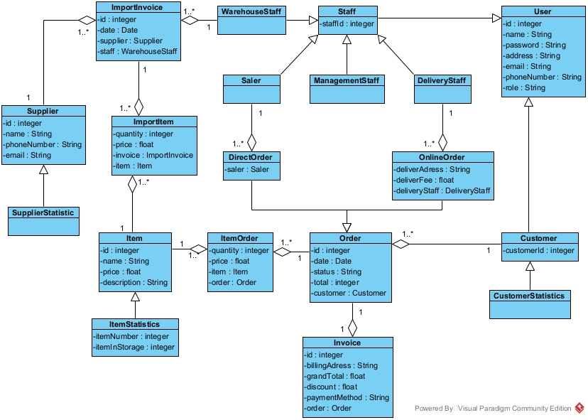

Database
- Step 1: For each class entity, create a table
  - User: tblUser
  - Staff: tblStaff
  - Customer: tblCustomer
  - Order: tblOrder
  - DirectOrder: tblDirectOrder
  - OnlineOrder: tblOnlineOrder
  - ImportInvoice: tblImportInvoice
  - Invoice: tblInvoice
  - Item: tblItem
  - Supplier: tblSupplier
  - ImportItem: tblImportItem
- Step 2: For each entity class, take all attribute type except entity attribute
  - tblUser:
    - id: integer(10)
    - name: varchar(255)
    - password: varchar(255)
    - address: varchar(255)
    - email: varchar(255)
    - phoneNumber: varchar(255)
    - role: varchar(255)
  - tblStaff:
    - staffId: integer(10)
    - tblUserid: integer(10)
  - tblCustomer:
    - customerId: integer(10)
    - tblUserid: integer(10)
  - tblOrder:
    - id: integer(10)
    - date: date
    - status: varchar(255)
    - total: float(10)
    - tblCustomercustomerId: integer(10)
  - tblInvoice:
    - id: integer(10)
    - billingAddress: varchar(255)
    - discount: float(10)
    - grandTotal: float(10)
    - paymentMethod: varchar(255)
    - tblOrderid: integer(10)
  - tblItemOrder
    - quantity: integer(10)
    - price: float(10)
    - tblItemid: integer(10)
    - tblOrderid: integer(10)
  - tblItem
    - id: integer(10)
    - name: varchar(255)
    - price: float(10)
    - description: varchar(255)
  - tblDirectOrder
    - tblStaffstaffId: integer(10)
    - tblOrderid: integer(10)
  - tblOnlineOrder
    - tblStaffstaffId: integer(10)
    - tblOrderid: integer(10)
    - deliverAdress: varchar(255)
    - deliverFee: integer(10)
  - tblImportInvoice
    - id: integer(10)
    - date: date
    - tblStaffstaffId: integer(10)
    - tblSupplierid: integer(10)
  - tblImportItem
    - quantity: integer(10)
    - price: float (10)
    - tblItemid: integer(10)
    - tblImportInvoiceid: integer(10)
  - tblSupplier
    - id: integer(10)
    - name: varchar(255)
    - phoneNumber: varchar(10)
    - email: varchar(255)
- Step 3: Consider quantity relationship between classes:
  - tblUser – tblStaff: 1 – 1
  - tblUser – tblCustomer: 1 – 1
  - tblStaff – tblDirectOrder: 1 – n
  - tblStaff – tblOnlineOrder: 1 – n
  - tblDirectOrder – tblOrder: 1 – 1
  - tblOnlineOrder – tblOrder: 1 – 1
  - tblCustomer – tblOrder: 1 – n
  - tblOrder – tblInvoice: 1 – 1
  - tblOrder – tblItemOrder: 1 – n
  - tblItem – tblItemOrder: 1 – n
  - tblStaff – tblImportInvoice: 1 – n
  - tblSupplier – tblImportInvoice: 1 – n
  - tblImportInvoice – tblImportItem: 1 – n
  - tblItem – tblImportItem: 1 -n
- Step 4: Add primary key and foreign key for all table
  - tblUser:
    - Primary Key: id
  - tblStaff:
    - Primary Key: staffId
    - Foreign Key: tblUserid → tblUser.id
  - tblCustomer:
    - Primary Key: customerId
    - Foreign Key: tblUserid → tblUser.id
  - tblOrder:
    - Primary Key: id
    - Foreign Key: tblCustomercustomerId → tblCustomer.customerId
  - tblInvoice:
    - Primary Key: id
    - Foreign Key: tblOrderid → tblOrder.id
  - tblItemOrder:
    - Primary Key: tblItemid, tblOrderid
      - Foreign Keys: tblItemid → tblItem.id,t blOrderid → tblOrder.id
  - tblItem:
    - Primary Key: id
  - tblDirectOrder:
    - Primary Key: tblOrderid
    - Foreign Keys: tblStaffstaffId → tblStaff.staffId, tblOrderid → tblOrder.id
  - tblOnlineOrder:
    - Primary Key: tblOrderid
    - Foreign Keys: tblStaffstaffId → tblStaff.staffId, tblOrderid → tblOrder.id
  - tblImportInvoice:
    - Primary Key: id
    - Foreign Keys: tblStaffstaffId → tblStaff.staffId, tblSupplierid → tblSupplier.id
  - tblImportItem:
    - Primary Key: tblItemid, tblImportInvoiceid
    - Foreign Keys: tblItemid → tblItem.id, tblImportInvoiceid → tblImportInvoice.id
  - tblSupplier
    - Primary Key: id
- Step 5: Remove abundant attribute
  - Attribute total in order
  - Attribute grandTotal in invoice
